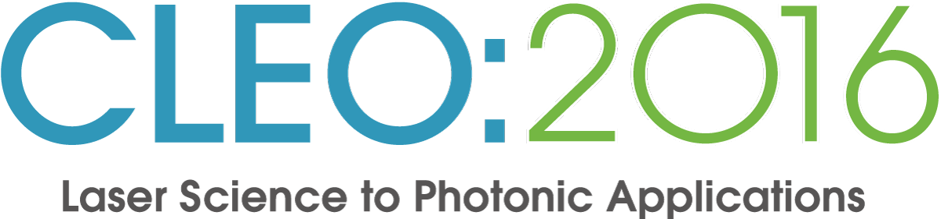 Exhibitor Newsletter 04/16
Technical Conference: 5-10 June 2016 CLEO: Expo 7-9 June 2016
 | Quick Links
- Register Now  - Book Your Hotel  - Customs & International Shipping  - 2016 Floor Plan/Exhibitor List |  | - Exhibitor Service Center  - Deadlines Checklist Attention!  - Hours of Operation  - Contact Us
 | Operations & Logistics

! The final deadline for submitting your company information for the PRINTED guide is 10 April 2016!
Any changes or submissions received after this deadline will not be reflected in the print version. Companies may continue to submit changes to their online digital booth at any time. Should a company miss this deadline, only the contact information as it appears in the CLEO: 2016 Exhibitor database will appear. Management reserves the right to edit submissions as necessary.
Submission Instructions
- Click on "Submit Company Description" on the left side of the Exhibitor Service Center page to go to the submission site.
- Select your Company Name from the List.
- Enter Password. The password is the Company Number located on your invoice and space confirmation.
- To ensure complete and accurate information for your listing in your online digital booth and CLEO Exhibit Buyers’ Guide, please review and submit the following:
Virtual Tradeshow (online only) | Printed Buyers’ Guide (in print only; submission deadline 10 April 2016)
Business Card | Business Card
Company Profile (all information) | Company Profile (website entry only)
Categories (choose up to 6 unless purchasing an upgrade) | Show Guide
Product Showcase | Categories (choose up to 6 unless purchasing an upgrade)
Please note the important Vendor Discount Deadline dates happening next month on 9 May!

The Exhibitor Service Manual is available to assist with your planning. To access the order forms, click on the Order Rental Items button at the bottom of the page. Use log in credentials:
Show name: CLEO
Show code: CLEO2016

Housing and Registration deadlines are coming soon! Find these links and more in the Exhibitor Service Center.

New CLEO Vendor! ICAT Expo, a division of ICAT Logistics, has been chosen to be the Official International Carrier for CLEO. They are able to provide competitive pricing, unmatched customer service, 24/7 live tracking and a team of international experts who will walk you through the entire shipping process. Let them show you how they can make shipping the easiest part of your job. Call 1-888-933-4228 or 1-443-459-8071, or email bwi.intl@icatlogistics.com today!

Forms: Before & After Hours Meetings Form
10+ Group Badge Pick Up Form
Laser Safety Inspection Form due no later than 9 May
We hope that your pre-show preparations are going well. Below you will find more useful information to ensure that your participation runs smoothly.

Hours of Operation and Shipping Information
Guidelines for Display Rules & Regulations
San Jose Union Rules
Safety & Security

Warning! Caution on Third Party Offerings

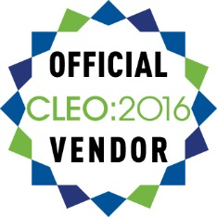
Please be vigilant if contacted by any company or service other than CLEO’s Official vendors who claim to be an official vendor for CLEO 2016. We have been made aware of other housing companies and/or service companies aggressively pursuing you. Please note that CLEO does not provide them with any contact information. Always look for this Official Vendor seal for CLEO 2016 on emails and correspondence.

Maximize Your Participation/PR Opportunities
Become a Sponsor: Sign up for a sponsorship now to ensure that you will be noticed by the top industry decision-makers at the premier international forum for scientific and technical optics. Email cleosales@osa.org for additional details including rates. Sponsorships are secured on a first-come, first-serve basis.
Promote Your Booth! Add the “We’re Exhibiting at CLEO” banner to your emails and website! Click here for images and instructions.
New this year! Free Exhibitor Invites Opportunity: Drive traffic to your booth! A great pre-show marketing tool, Exhibitor Invites is an easy to use program proven to be one of the most powerful ways to ensure your key contacts attend CLEO. Bonus for using Exhibitor Invites! All participating companies will be entered into a drawing for a Go-Pro Hero+ camera! To get started visit: www.exhibitorinvites.com/CLEO.

The CLEO PR Team has several FREE opportunities to maximize your presence on-site by promoting your news and announcement to media and analysts attending the show. Click here for details and contact information.

On the show floor

- Market Focus (on-floor business programming)
- Technology Transfer (on-floor business programming)
- Poster Sessions
- Student Lounge
- Technology Playground
- Professional networking opportunities such as the VIP Industry Leaders and OSA's Executive Forum events
- Free pizza lunch—Take advantage of the final networking opportunity with the exhibitors by enjoying a slice of pizza on the exhibit floor.

Contacts and more…

Registration badges, registration tech support, registration billing - cleo@compusystems.com
Hotel information, reservations, customer service – cleo@onpeak.com
Operations & Exhibitor Services, Logistics – cleoexhibits@osa.org
Exhibits, Promotional Opportunities & Sponsorships - cleosales@osa.org
Career Center, Booth Location/Size Changes - cleosales@osa.org
Exhibit Payments, Invoices, or Primary Contact Changes – cleoaccounts@osa.org
Media/PR – randerson@osa.org or jmiller@osa.org

Questions? CLEO Show Management is happy to help at cleosales@osa.org

